Problem

The Latin alphabet contains 26 characters and telephones only have ten digits on the keypad. We would like to make it easier to write a message to your friend using a sequence of keypresses to indicate the desired characters. The letters are mapped onto the digits as shown below. To insert the character B for instance, the program would press 22. In order to insert two characters in sequence from the same key, the user must pause before pressing the key a second time. The space character ' ' should be printed to indicate a pause. For example, 2 2 indicates AA whereas 22 indicates B.

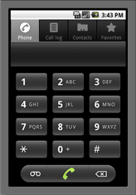

Input

The first line of input gives the number of cases, **N**. **N** test cases follow. Each case is a line of text formatted as

desired_message

Each message will consist of only lowercase characters a-z and space characters ' '. Pressing zero emits a space.

Output

For each test case, output one line containing "Case #**x**: " followed by the message translated into the sequence of keypresses.

Limits

1 ≤ **N** ≤ 100.

Small dataset

1 ≤ length of message in characters ≤ 15.

Large dataset

1 ≤ length of message in characters ≤ 1000.

Sample

|  |  |
| --- | --- |
| Input | Output |
| 4 hi yes foo  bar hello world | Case #1: 44 444 Case #2: 999337777 Case #3: 333666 6660 022 2777 Case #4: 4433555 555666096667775553 |